**SQL HANDSON 3**

**NAME – ASHI JAIN**

**BATCH – IBM .NET**

**Prepare Sample Data to Practice SQL Skill.**

Sample Table – Worker

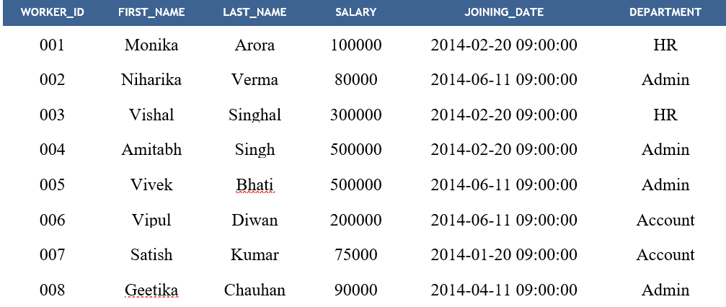

Sample Table – Bonus

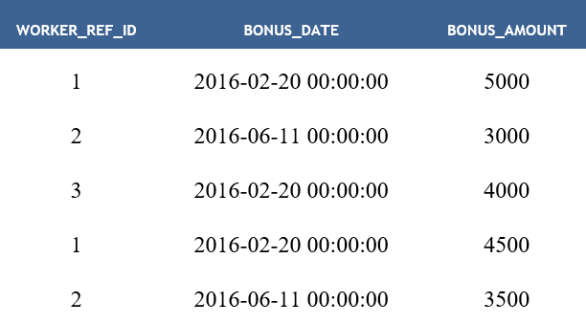

Sample Table – Title

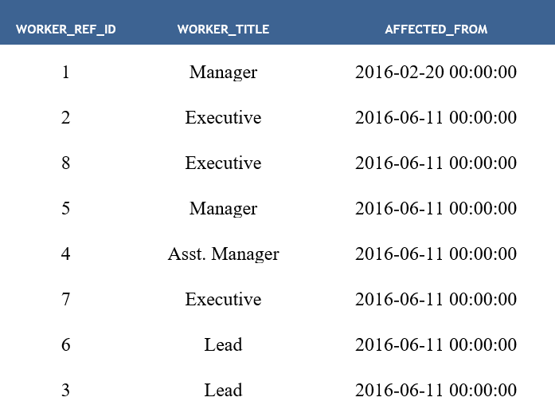

-- creating the table named "Worker"

create table Worker (

WORKER_ID int primary key,

FIRST_NAME varchar(20),

LAST_NAME varchar(20),

SALARY bigint,

JOINING_DATE datetime,

DEPARTMENT varchar(20)

)

-- creating the table named "Bonus"

create table Bonus (

WORKER_REF_ID int,

constraint fk_worker_ref_id foreign key (WORKER_REF_ID) references Worker(WORKER_ID),

BONUS_DATE datetime,

BONUS_AMOUNT int

)

-- creating the table named "Title"

create table Title (

WORKER_REF_ID int,

constraint fk2_worker_ref_id foreign key (WORKER_REF_ID) references Worker(WORKER_ID),

WORKER_TITLE varchar(20),

AFFECTED_FROM datetime

)

-- inserting values to the table named "Worker"

insert into Worker (WORKER_ID, FIRST_NAME, LAST_NAME, SALARY, JOINING_DATE, DEPARTMENT)

values

(001, 'Monika', 'Arora', 10000, '2014-02-20 09:00:00', 'HR'),

(002, 'Niharika', 'Verma', 80000, '2014-06-11 09:00:00', 'Admin'),

(003, 'Vishal', 'Singhal', 30000, '2014-02-20 09:00:00', 'HR'),

(004, 'Amitabh', 'Singh', 50000, '2014-02-20 09:00:00', 'Admin'),

(005, 'Vivek', 'Bhati', 50000,'2014-06-11 09:00:00', 'Admin'),

(006, 'Vipul', 'Diwan', 20000, '2014-06-11 09:00:00', 'Account'),

(007, 'Satish', 'Kumar', 75000, '2014-01-20 09:00:00', 'Account'),

(008, 'Geetika', 'Chauhan', 90000, '2014-04-11 09:00:00', 'Admin')

select * from Worker

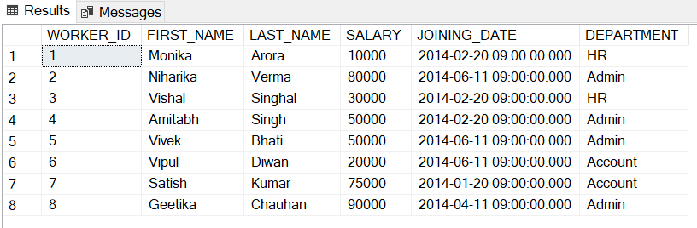

-- inserting values to the table named "Bonus"

insert into Bonus (WORKER_REF_ID, BONUS_DATE, BONUS_AMOUNT)

values

(1, '2016-02-20 00:00:00', 5000),

(2, '2016-06-11 00:00:00', 3000),

(3, '2016-02-20 00:00:00', 4000),

(1, '2016-02-20 00:00:00', 4500),

(2, '2016-06-11 00:00:00', 3500)

select * from Bonus

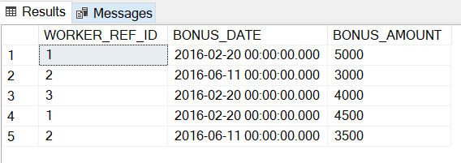

-- inserting values to the table named "Title"

insert into Title (WORKER_REF_ID, WORKER_TITLE, AFFECTED_FROM)

values

(1, 'Manager', '2016-02-20 00:00:00'),

(2, 'Executive', '2016-06-11 00:00:00'),

(8, 'Executive', '2016-06-11 00:00:00'),

(5, 'Manager', '2016-06-11 00:00:00'),

(4, 'Asst. Manager', '2016-06-11 00:00:00'),

(7, 'Executive', '2016-06-11 00:00:00'),

(6, 'Lead', '2016-06-11 00:00:00'),

(3, 'Lead', '2016-06-11 00:00:00')

select * from Title

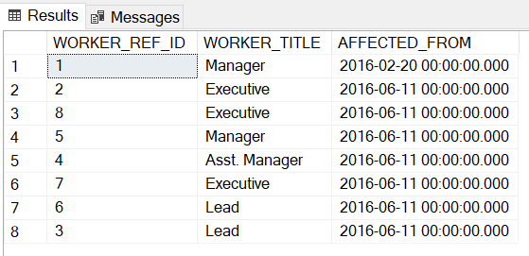

--Q-1. Write An SQL Query To Fetch “FIRST_NAME” From Worker Table Using The Alias Name As <WORKER_NAME>.

select FIRST_NAME as WORKER_NAME from Worker

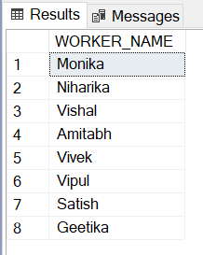

--Q-2. Write An SQL Query To Fetch “FIRST_NAME” From Worker Table In Upper Case

select UPPER(FIRST_NAME) from Worker

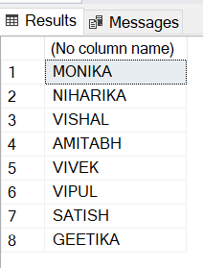

--Q-3. Write An SQL Query To Fetch Unique Values Of DEPARTMENT From Worker Table.

select distinct DEPARTMENT from Worker

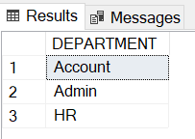

--Q-4. Write An SQL Query To Print First Three Characters Of FIRST_NAME From Worker Table.

select SUBSTRING(FIRST_NAME,1,3) from Worker

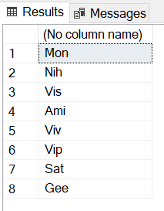

--Q-5. Write An SQL Query To Find The Position Of The Alphabet (‘A’) In The First Name Column ‘Amitabh’ From Worker Table.

select CHARINDEX('A','Amitabh')

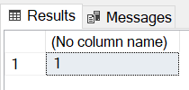

--Q-6. Write An SQL Query To Print The FIRST_NAME From Worker Table After Removing White Spaces From The Right Side.

Select RTRIM(FIRST_NAME) from Worker

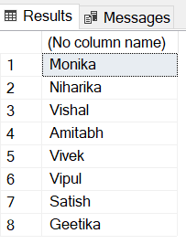

--Q-7. Write An SQL Query To Print The DEPARTMENT From Worker Table After Removing White Spaces From The Left Side.

Select LTRIM(FIRST_NAME) from Worker

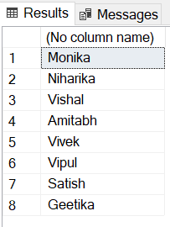

--Q-8. Write An SQL Query That Fetches The Unique Values Of DEPARTMENT From Worker Table And Prints Its Length.

select distinct DEPARTMENT, LEN(DEPARTMENT) from Worker

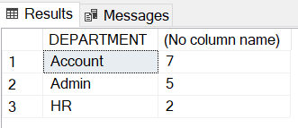

--Q-9. Write An SQL Query To Print The FIRST_NAME From Worker Table After Replacing ‘a’ With ‘A’.

select REPLACE(FIRST_NAME,'a','A') from Worker

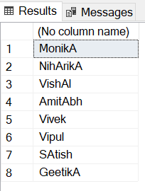

--Q-10. Write An SQL Query To Print The FIRST_NAME And LAST_NAME From Worker Table Into A Single Column COMPLETE_NAME. A Space Char Should Separate Them.

select FIRST_NAME + ' ' + LAST_NAME as COMPLETE_NAME from Worker

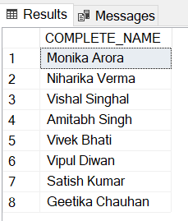

--Q-11. Write An SQL Query To Print All Worker Details From The Worker Table Order By FIRST_NAME Ascending.

select * from Worker order by FIRST_NAME

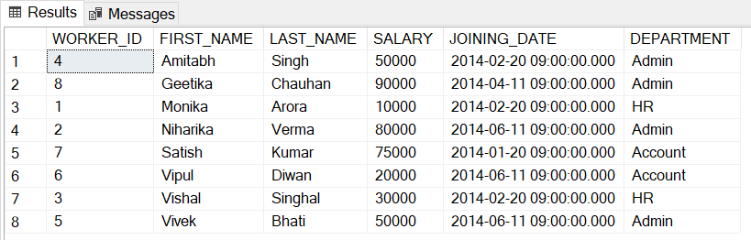

--Q-12. Write An SQL Query To Print All Worker Details From The Worker Table Order By FIRST_NAME Ascending And DEPARTMENT Descending.

select * from Worker order by FIRST_NAME asc, DEPARTMENT desc

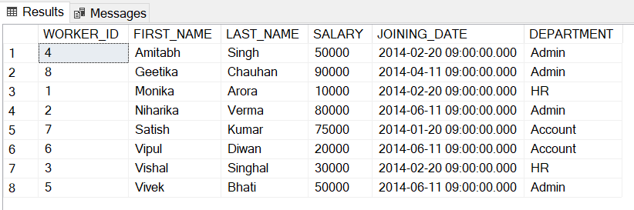

--Q-13. Write An SQL Query To Print Details For Workers With The First Name As “Vipul” And “Satish” From Worker Table.

select * from Worker where FIRST_NAME in ('Vipul', 'Satish')

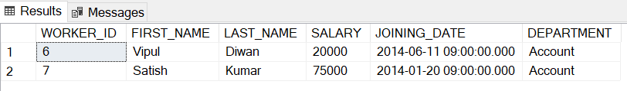

--Q-14. Write An SQL Query To Print Details Of Workers Excluding First Names, “Vipul” And “Satish” From Worker Table.

select * from Worker where FIRST_NAME not in ('Vipul', 'Satish')

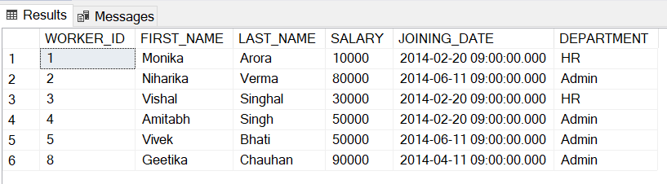

--Q-15. Write An SQL Query To Print Details Of Workers With DEPARTMENT Name As “Admin”.

select * from Worker where DEPARTMENT in ('Admin')

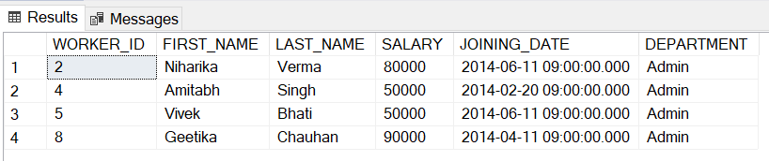

--Q-16. Write An SQL Query To Print Details Of The Workers Whose FIRST_NAME Contains ‘A’.

select * from Worker where FIRST_NAME like '%A%'

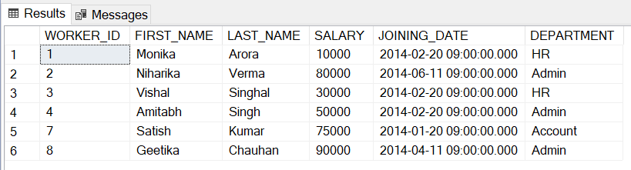

--Q-17. Write An SQL Query To Print Details Of The Workers Whose FIRST_NAME Ends With ‘A’.

select * from Worker where FIRST_NAME like '%A'

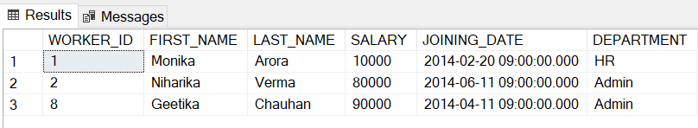

--Q-18. Write An SQL Query To Print Details Of The Workers Whose FIRST_NAME Ends With ‘H’ And Contains Six Alphabets.

select * from Worker where FIRST_NAME like '%H' and LEN(FIRST_NAME)=6

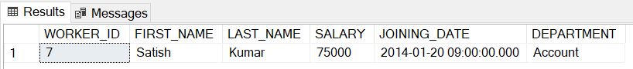

--Q-19. Write An SQL Query To Print Details Of The Workers Whose SALARY Lies Between 100000 And 500000.

select * from Worker where SALARY between 100000 and 500000

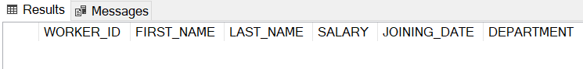

--Q-20. Write An SQL Query To Print Details Of The Workers Who Have Joined In Feb’2014.

select * from Worker where YEAR(JOINING_DATE)=2014 and MONTH(JOINING_DATE)=02

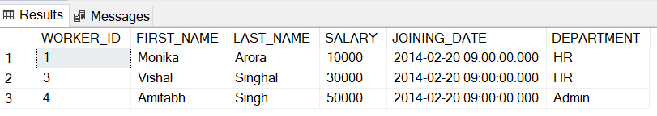

--Q-21. Write An SQL Query To Fetch The Count Of Employees Working In The Department ‘Admin’.

select COUNT(*) from Worker where DEPARTMENT='Admin'

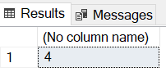

--Q-22. Write An SQL Query To Fetch Worker Names With Salaries >= 50000 And <= 100000

select FIRST_NAME + ' ' + LAST_NAME as COMPLETE_NAME

from Worker

where SALARY >= 50000 and SALARY <= 100000

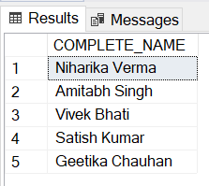

--Q-23. Write An SQL Query To Fetch The No. Of Workers For Each Department In The Descending Order.

select COUNT(WORKER_ID) as CountofWorkers from Worker

group by DEPARTMENT

order by CountofWorkers desc

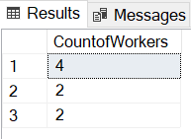

--Q-24. Write An SQL Query To Print Details Of The Workers Who Are Also Managers

select w.WORKER_ID, w.FIRST_NAME, w.LAST_NAME, w.SALARY, w.JOINING_DATE, w.DEPARTMENT, t.WORKER_TITLE

from Worker w

inner join

Title t

on w.WORKER_ID = t.WORKER_REF_ID and t.WORKER_TITLE='Manager'

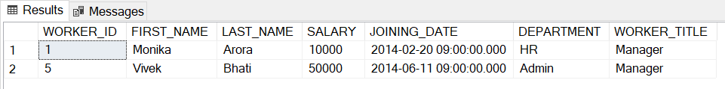

--Q-25. Write An SQL Query To Fetch Duplicate Records Having Matching Data In Some Fields Of A Table.

select WORKER_TITLE, COUNT(*)

from Title

group by WORKER_TITLE

having COUNT(*)>1

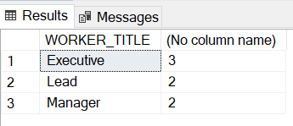

--Q-26. Write An SQL Query To Show Only Odd Rows From A Table

select * from Worker where WORKER_ID%2!=0

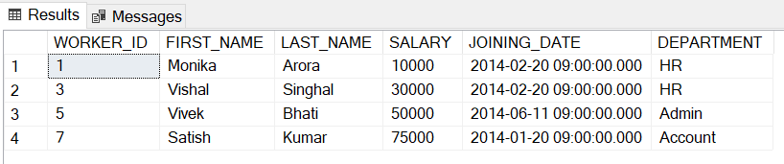

--Q-27. Write An SQL Query To Show Only Even Rows From A Table.

select * from Worker where WORKER_ID%2=0

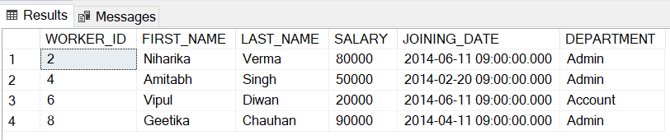

--Q-28. Write An SQL Query To Clone A New Table From Another Table.

select * into Worker2

from Worker

select * from Worker2

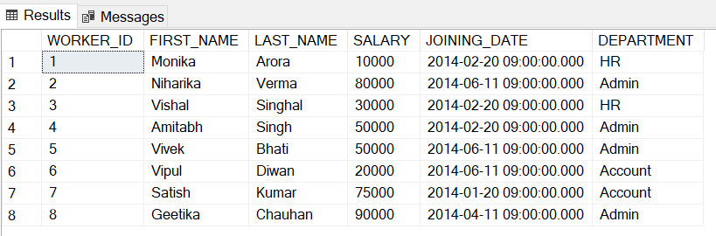

--Q-29. Write An SQL Query To Fetch Intersecting Records Of Two Tables.

(select * from Worker) INTERSECT (select * from Worker2)

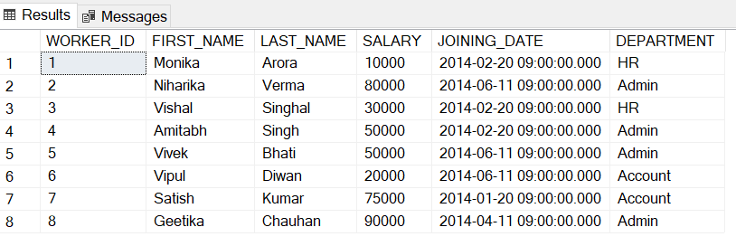

--Q-30. Write An SQL Query To Show Records From One Table That Another Table Does Not Have.

select * from Worker

select * from Bonus

select * from

Worker w

left join

Bonus b

on w.WORKER_ID = b.WORKER_REF_ID

where b.WORKER_REF_ID is NULL

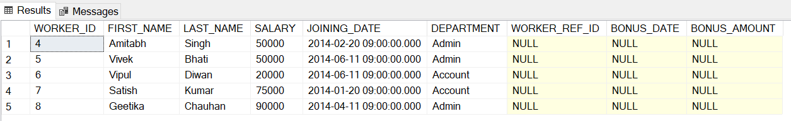

--Q-31. Write An SQL Query To Show The Current Date And Time.

select getdate()

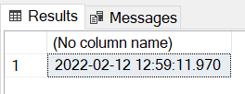

--Q-32. Write An SQL Query To Show The Top N (Say 5) Records Of A Table.

select top 5 * from Worker

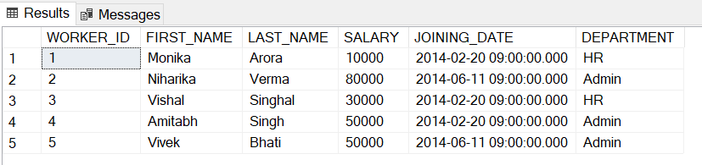

--Q-33. Write An SQL Query To Determine The Nth (Say N=5) Highest Salary From A Table.

select SALARY

from Worker w1

where 5-1 = (select COUNT(distinct SALARY) from Worker w2

where w2.SALARY > w1.SALARY)

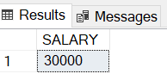

--Q-34. Write An SQL Query To Determine The 5th Highest Salary Without Using TOP Or Limit Method.

select SALARY

from Worker w1

where 5-1 = (select COUNT(distinct SALARY) from Worker w2

where w2.SALARY > w1.SALARY)



--Q-35. Write An SQL Query To Fetch The List Of Employees With The Same Salary.

select distinct w1.WORKER_ID, w1.FIRST_NAME, w1.LAST_NAME, w1.SALARY, w1.JOINING_DATE, w1.DEPARTMENT

from

Worker w1

inner join

Worker w2

on w1.SALARY=w2.SALARY and w1.WORKER_ID!=w2.WORKER_ID

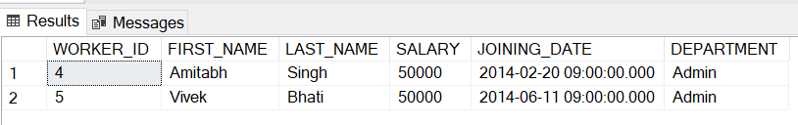

--Q-36. Write An SQL Query To Show The Second Highest Salary From A Table.

select MAX(SALARY) from Worker

where SALARY not in (select MAX(SALARY) from Worker)

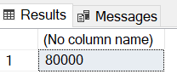

--Q-37. Write An SQL Query To Show One Row Twice In Results From A Table.

select w1.WORKER_ID, w1.FIRST_NAME, w1.LAST_NAME, w1.SALARY, w1.JOINING_DATE, w1.DEPARTMENT from

Worker w1

union all

select w2.WORKER_ID, w2.FIRST_NAME, w2.LAST_NAME, w2.SALARY, w2.JOINING_DATE, w2.DEPARTMENT from

Worker w2

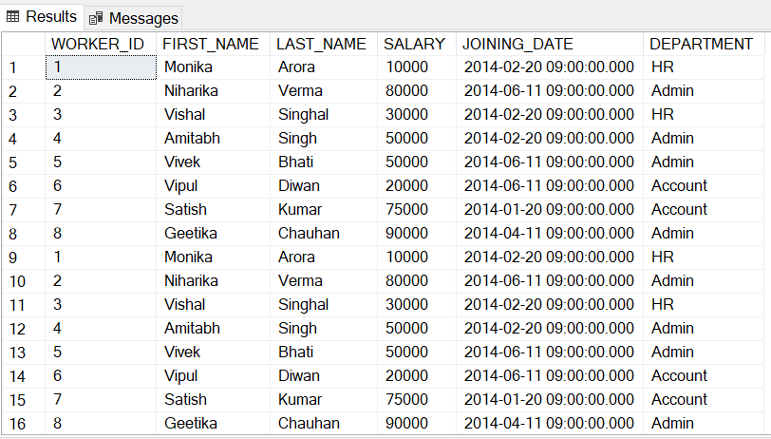

--Q-38. Write An SQL Query To Fetch Intersecting Records Of Two Tables.

(select * from Worker) INTERSECT (select * from Worker2)

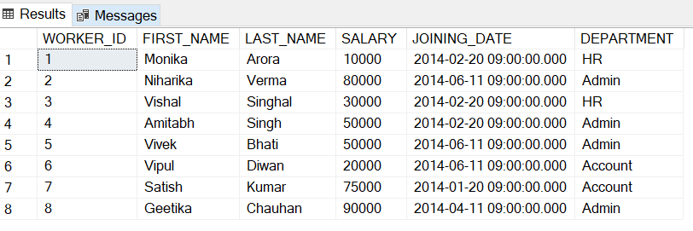

--Q-39. Write An SQL Query To Fetch The First 50% Records From A Table

select TOP 50 PERCENT * from Worker

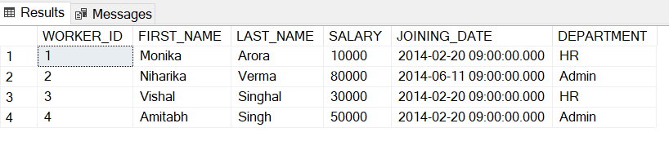

--Q-40. Write An SQL Query To Fetch The Departments That Have Less Than Five People In It.

select DEPARTMENT from Worker

group by

DEPARTMENT

having COUNT(WORKER_ID) < 5

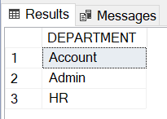

--Q-41. Write An SQL Query To Show All Departments Along With The Number Of People In There.

select DEPARTMENT, COUNT(WORKER_ID) from Worker

group by

DEPARTMENT

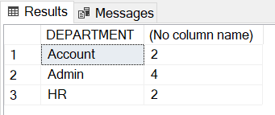

--Q-42. Write An SQL Query To Show The Last Record From A Table.

select * from Worker

where

WORKER_ID = (select MAX(WORKER_ID) from Worker)

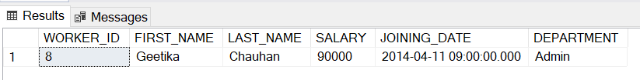

--Q-43. Write An SQL Query To Fetch The First Row Of A Table.

select * from Worker

where

WORKER_ID = (select MIN(WORKER_ID) from Worker)

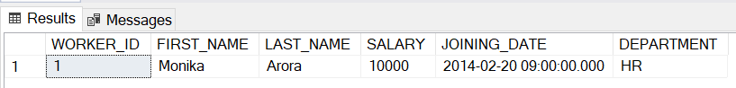

--Q-44. Write An SQL Query To Fetch The Last Five Records From A Table.

select top 5 * from Worker order by WORKER_ID desc

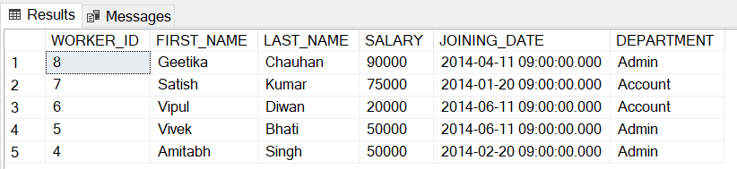

--Q-45. Write An SQL Query To Print The Name Of Employees Having The Highest Salary In Each Department.

select FIRST_NAME, DEPARTMENT, SALARY

from Worker

where SALARY in (select MAX(SALARY)

from Worker

group by DEPARTMENT

)

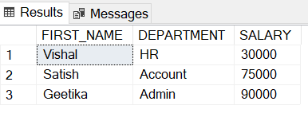

--Q-46. Write An SQL Query To Fetch Three Max Salaries From A Table.

select distinct SALARY

from Worker w1

WHERE 3 >= (SELECT count(distinct SALARY)

from Worker w2

WHERE w1.SALARY <= w2.SALARY)

order by w1.SALARY desc

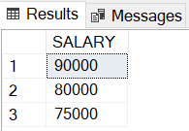

--Q-47. Write An SQL Query To Fetch Three Min Salaries From A Table.

select distinct SALARY

from Worker w1

where 3 >= (select COUNT(distinct SALARY)

from Worker w2

where w2.SALARY <= w1.SALARY)

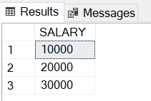

--Q-48. Write An SQL Query To Fetch Nth (Say N=5) Max Salaries From A Table.

select distinct SALARY

from Worker w1

where 5 >= (select COUNT(distinct SALARY)

from Worker w2

where w2.SALARY >= w1.SALARY)

order by w1.SALARY desc

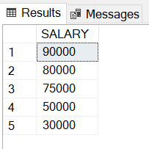

--Q-49. Write An SQL Query To Fetch Departments Along With The Total Salaries Paid For Each Of Them.

select DEPARTMENT, sum(Salary) from worker group by DEPARTMENT

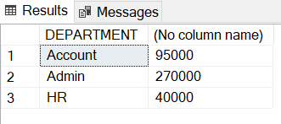

--Q-50. Write An SQL Query To Fetch The Names Of Workers Who Earn The Highest Salary.

select FIRST_NAME + ' ' + LAST_NAME from Worker where SALARY = (select MAX(SALARY) from Worker)

